**Title : Importance of Different Sources of Water Available Nearby**

**1. Introduction**

Water is a crucial natural resource that supports all forms of life and is essential for domestic, agricultural, industrial, and recreational activities. The availability of diverse water sources in any region plays a critical role in maintaining the local ecosystem, supporting the population, and ensuring sustainable development. This report highlights the significance of different water sources found nearby, such as rivers, lakes, groundwater, and rainwater, emphasizing their roles in the community and environment.

**1. Rivers**

Rivers are one of the most important sources of fresh water. They provide water for:

- Domestic use : Rivers supply drinking water and water for household chores like cooking, cleaning, and washing.

- Agriculture : Rivers are vital for irrigation in nearby agricultural lands. They support crop production and ensure food security.

- Industry : Many industries rely on river water for processes like cooling, cleaning, and manufacturing.

- Ecosystem support : Rivers create habitats for diverse species of flora and fauna, maintaining biodiversity.

**Importance:**

- Continuous flow of fresh water

- Availability for various sectors

- Maintenance of local biodiversity

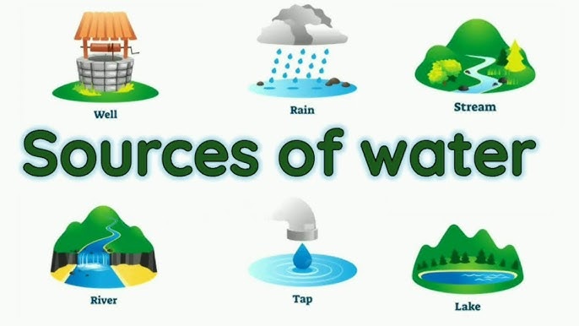

**2. Lakes and Reservoirs**

Lakes and reservoirs are essential for:

- Water storage : They store water during monsoon seasons, ensuring a supply during dry periods.

- Recreation and tourism : Lakes are popular spots for recreational activities like boating, fishing, and tourism, contributing to local economies.

- Wildlife habitats : Lakes support aquatic ecosystems, providing breeding grounds for fish, birds, and other wildlife.

- Flood control : Reservoirs help manage excess water during heavy rains, reducing the risk of floods.

Importance:

- Reliable water storage

- Ecological and recreational value

- Flood mitigation

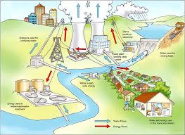

**3. Groundwater**

Groundwater is accessed through wells and boreholes. It is used for:

- Drinking water : Groundwater is a major source of potable water, especially in rural areas.

- Agriculture : Farmers rely on groundwater for irrigation, especially when surface water sources are scarce.

- Industrial use : Factories in many areas pump groundwater for their operational needs.

- Drought resilience : Groundwater reserves serve as a buffer during periods of drought, ensuring a continuous water supply.

**Importance:**

- Reliable and consistent source of water

- Crucial for agriculture and drinking purposes

- Resilience against seasonal changes

**4. Rainwater**

Rainwater is a renewable resource that can be harvested and stored. It is important for:

- Domestic use : Collected rainwater can be used for drinking, cooking, and irrigation, especially during water shortages.

- Agricultural use : Rainwater supports farming and reduces the need for artificial irrigation during monsoons.

- Recharge of groundwater : Rainwater replenishes underground aquifers, contributing to groundwater levels.

- Reducing flood risk : Proper rainwater harvesting reduces surface runoff, minimizing the risk of flooding in urban and rural areas.

**Importance:**

- Sustainable and eco-friendly

- Reduces pressure on other water sources

- Helps recharge groundwater

**4. Importance of Water Sources**

**4.1. Drinking Water**

Access to clean and safe drinking water is fundamental for human health. The nearby rivers, lakes, wells, and borewells serve as the primary sources for drinking water in many regions. Surface water is often treated at water treatment plants to make it safe for human consumption, while groundwater is typically filtered through natural processes.

**4.2. Agriculture and Irrigation**

In many communities, agriculture is the backbone of the local economy. Adequate water supply is essential for crop growth, and rivers, lakes, and groundwater sources such as wells and borewells play a pivotal role in irrigation. Water availability during critical growing periods can directly influence crop yields and food security.

**4.3. Industrial Use**

Industries rely heavily on water for manufacturing processes, cooling systems, and cleaning. Nearby water sources, whether surface or groundwater, are crucial for industrial development. Factories often establish themselves close to rivers and lakes to meet their operational water requirements. However, industrial pollution can also pose risks to these sources.

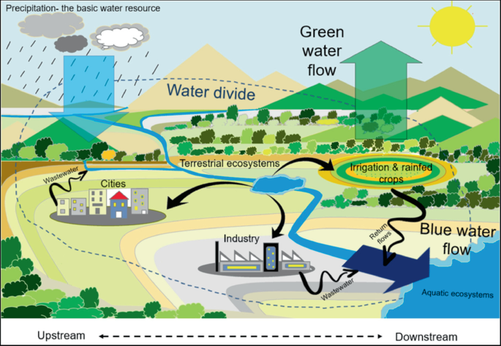

**5. Challenges Related to Water Availability**

Despite the abundance of water sources, several challenges threaten water availability:

* **Pollution:** Industrial discharge, agricultural runoff, and untreated sewage contribute to the contamination of rivers, lakes, and groundwater, making the water unsafe for consumption.
* **Overuse:** Excessive extraction of groundwater from wells and borewells, combined with inefficient irrigation practices, leads to the depletion of these sources.
* **Climate Change:** Irregular rainfall patterns, droughts, and rising temperatures due to climate change are affecting water availability, reducing surface water levels and stressing groundwater reserves.

**6. Water Conservation Strategies**

Given the increasing demand for water and the challenges of water scarcity, conservation strategies are critical for sustaining water resources:

* **Rainwater Harvesting:** This method involves collecting and storing rainwater for future use. By capturing rainwater, communities can reduce their dependence on traditional water sources and ensure a stable supply during dry periods.
* **Sustainable Agriculture Practices:** Implementing water-efficient irrigation systems, such as drip irrigation and sprinkler systems, can significantly reduce water wastage in agriculture.
* **Water Recycling and Reuse:** Treating and reusing wastewater for industrial or agricultural purposes can help alleviate the strain on freshwater sources.

**Conclusion :**

The availability and sustainable use of various water sources—rivers, lakes, groundwater, and rainwater—are essential for the well-being of any community. Rivers and lakes provide fresh water for multiple purposes, while groundwater ensures long-term water security. Rainwater harvesting helps reduce dependence on other water sources. Protecting these sources from pollution and overuse is critical for future water security and environmental balance.